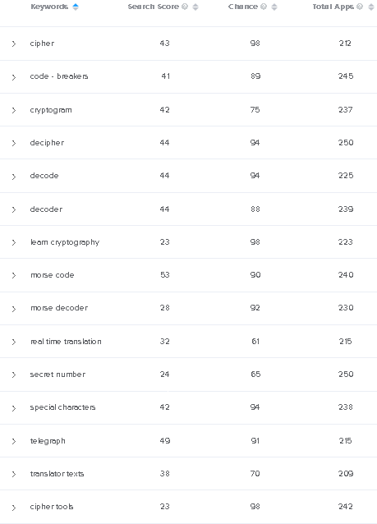

**Suggested Title: Morse Code – Translator Texts to Morse Decoder**

**Short description:**

Translate text to Morse code or vice versa in real time translation.

**Long description:**

Translate text to Morse code or decipher Morse code by translating them to text! It’s a simple, user friendly, but useful app that can help you in a lot of ways. You can decipher or decode Morse codes, you can create secret number or learn to be a cipher or learn cryptography, and many more! If you think of yourself as a codebreaker, download and try our Morse code cypher tool! Don’t let the special characters or dots and dashes befuddle you.

FEATURES OF MORSE CODE CIPHER TOOL:

* Clean, modern app design and interface.
* Super easy to use.
* Realtime translation: type in the word or code and we will translate it to you immediately.
* Decode from Morse to text or text to Morse.
* Press the speaker button to hear the code in sound.
* Copy the text by pressing copy button.
* Type in dot and dash using our built-in Morse keyboard.
* Open Source (https://github.com/Crazy-Marvin/Morse)
* More features coming up later!

What is Morse code? Morse code is a system to encode letters and numbers to dash and dot signs. The duration of the dash is three times the duration of a dot. Each dot or dash is followed by period of signal absence, called a space, equal to the dot duration. Morse code was first used for communicating via telegraph. The most well-known Morse code is SOS, which is used to signal an emergency. Aside from typing dots and dash, you can also signal Morse code by turning light on and off, sounding a horn or tapping, and many more. You can use Morse code to transmit messages easily via various means if the recipient understands Morse code. If they don’t, they can use our cipher tool to find out the password, secret number, or any info you want to relay.

Since people rarely communicate via telegraph, nowadays there are very few people who can memorize Morse codes. Instead, it has become a way to encode something or special characters for special purposes. Of course, these special characters are still widely used in many situations, you don’t know when you are going to really need it. It’s a useful language to know even if you just want to learn cryptography or cryptogram for fun.

How Morse is useful for you:

1. Tell others when you are in a dangerous situation (SOS).
2. Hide your secret number or password via dots and dashes.
3. Cipher/ Decipher hidden clues in games.
4. Learn cryptography or cryptogram through learning Morse codes.
5. Become a codebreaker by breaking secret codes in real time translation.
6. And many more!

So, what are you waiting for? Use our Morse code cipher tool to decipher Morse code to text or text to Morse code now! As a codebreaker & cryptogram enthusiast, our cipher tool is a must have! It is useful for all of you. Just try it out.

---

We hope that you enjoy using our cipher tool to decode, to learn cryptography, or other purposes. If you do, please support our Morse decoder app by giving a rating and review on our Google Play store page and/or a star on GitHub. It will only take a minute and it will mean the world for us!

If you have problems in using Morse app, please write us an email or open an issue on GitHub. We will respond immediately and fix the bug as soon as we can.